Kernel Holding S.A. (WSE:KER)
Kernel is a vertical integrated agricultural company. Its main activities are:
- Farming (corn, wheat, sunflower, soybean, rapeseed, barley, etc);
- Silo storage and rail-to-ship transshipment services;
- Soft commodities (corn, wheat, barley, sunflower, soybean) trading;
- Sunflower oil extraction, trading in bulk and retail bottled oil.
All these activities support each other and Company believes, that it extracts great synergy effect from its vertical integrated business model.
Its infrastructure includes:
- 385 000 hectares of leasehold farmland;
- over 30 silos with a total storage capacity of 2.8 million tons;
- 2 Black Sea deepwater grain export terminals: in Ukraine (4 mtpa capacity) and 50% stake in terminal of 4 mtpa capacity in Russia;
- 7 own oilseeds crushing plants and 1 is used under tolling agreement. Total capacity of 3.5 mtpa of sunflower seeds (abt 1.5 mtpa of sunflower oil).
Company has strong balance sheet with Debt/EBITDA ratio of 0.8; P/E ratio of its shares of 5.6 makes its stock look very attractive. Main non-management shareholders are: PZU (Polish insurer), Cascade Investment LLC (Bill Gates) Cascade Investment Fund (Vitaliy Khomutynnik) and Polish pension funds. Average daily trading volume of Company’s shares on Warsaw Stock Exchange is abt $1.5 mio. Kernel is a member of WIG20 index of the Warsaw Stock Exchange.
Company issued $500M Eurobonds at 8.875% per annum (8.75% semi-annual coupon). Proceedings to be used “to repay outstanding indebtedness, finance working capital and for general corporate purposes, which may include acquisitions, should opportunities arise” (source: Prospectus). By another source, “money raised through Kernel's Eurobond will be used to increase capacity at its Black Sea grain terminal to 8 million tonnes from 4 million tonnes and to buy an oil processing plant with production capacity of up to 1.5 million tonnes. The company will also increase its land holdings to 200,000 hectares”. Also: Kernel confirmed its i ntention to start new port terminal construction in Chernomorsk. Construction is to be started in following months, total transhipment capacity is to make 4M tons, estimated amount of investments – USD 100M, terminal is to be launched in Y2018. By information from conference call: Kernel will concentrate its efforts on realization of investment program. Update on the program (source of financing is to be operating cash flow generated by the company), its estimated costs and probability of realization in short-term perspective are as follows:
- Expansion of grains port terminal capacity in Chernomorsk (Ukraine) from 4M tons up to 8M tons (investment budget – USD 120M, thereof USD 40M to be spent in Y2017), project is on the way now.
- Purchase of oilseeds crusher(s) with 1-1.5M tons capacity (estimated cost is up to USD 200M, which is higher vs. our previous estimate of up to USD 150M). In a view of low margins (as crushing capacities in Ukraine (18.5M tons) are higher vs. raw materials availability (record-high sunflower seeds crop in Ukraine in current season made 13.6M tons)), Kernel expects industry consolidation, though notes that at the moment crushers owners are rather unwilling to sell their assets, so there is uncertainty related to this investment.
- Increase of land bank by 200k ha (estimated cost – USD 150M, generally in line with our estimations). It was disclosed that Kernel is interesting in purchase of Mriya assets (though negotiations are on their initial stage). In general, taking into account good yields and margins of Ukrainian farmers in this season, current prices of farming companies are quite high, which slows down process of Kernel expansion on this side as well
I would suggest that truth is somewhere in the middle:
- Company constantly maintains its Debt/Equity ratio on a low levels (0.76 as of 31st of December 2016; in the range of 0.6-0.8 from 2011)
- On another hand Company’s dividend policy ($0.25 per share, less than 10% of EPS for FY2016) suggests that it is focused on growth. Given that EBITDA margin was higher than Eurobonds interest in each of the last 9 years (and in all segments except grain trading) one can expect that additional financial leverage will increase EPS.
So, the baseline scenario would be what proceedings from the bond issuance will be spent on:
- Quarterly increase of expansion CAPEX by $10M (Chernomorsk port terminal expansion);
- Interest bearing debt repayment in the amount of $__M. During last five years cost of debt was in a range of 10% - 14%;
- Cash and cash equivalents increase by $__M as Company seeks for acquisition opportunities.
90% of Company’s revenue is USD denominated, Company doesn’t have assets on a conflict area (Crimea, East of Ukraine). Key risks are:
- Because of law restrictions Company doesn’t own land it uses for farming;
- Sunflower oil production uses only 6-7% of its own raw materials;
- Increase of competitiveness in silo and transshipment services. Especially amid low harvest in Ukraine.
Segments.
Company states that its segments provide diversification and thus decrease volatility of its performance. It’s true to some extent: correlation between segment’s contribution to EBITDA is low.
However, in my perception there should be some common dependency of all segment’s contribution to EBITDA on Ukraine’s total harvest. This is because more than 90% of a feedstock for oil crushing, approximately 75% of Company’s grain exports and export terminal throughput and 50% of silo service intake volumes are originated from third-party farmers. Also the harvest yields of Kernel don’t differentiate a lot from Ukraine’s average performance (FY2015 and FY2016 are the different story though).
correlation between segment’s contribution to EBITDA | Sunflower oil | Grain and infrastructure | Farming
Sunflower oil | 1,0 | 0,2 | 0,2
Grain and infrastructure | 0,2 | 1,0 | -0,1
Farming | 0,2 | -0,1 | 1,0
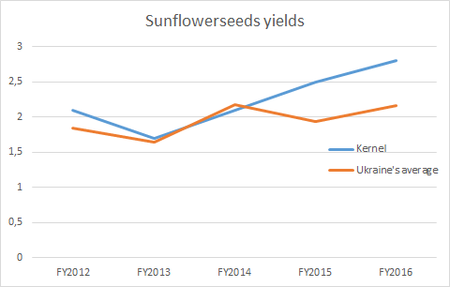
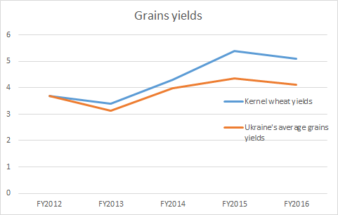

Source: Annual reports, Ukrstat

Contribution of Farming to EBITDA is most volatile. And there is a big question regarding cause of FY2014 loss as harvesting was good in that year.
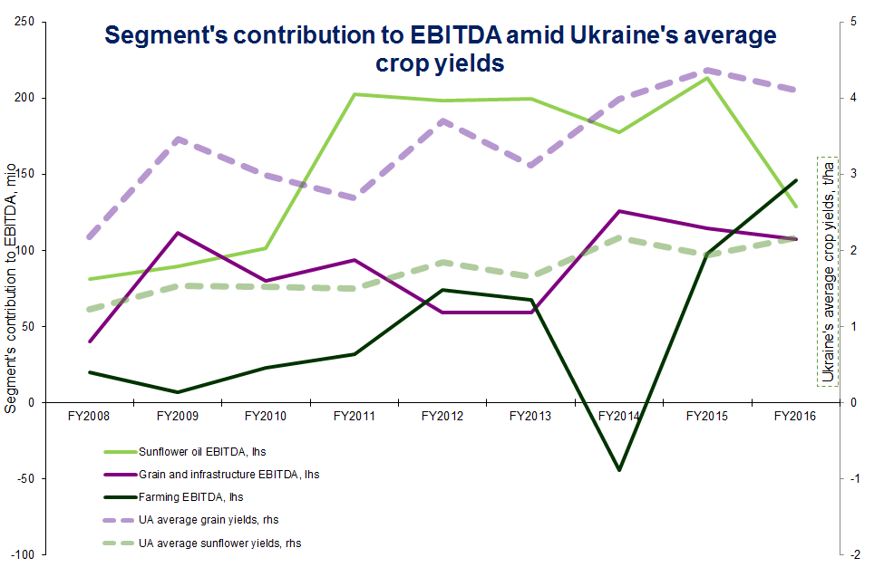

Sunflower oil
Grain and infrastructure
Farming

Comparison to other companies (see Exhibit 1).
It’s not easy task to find a peer for the Company in order to compare them. There are several grain traders that aren’t involved in farming and food processing too much. These companies are typically by the order of magnitude bigger than Kernel (“ABCD” companies).
There are some edible oil producers also. They are characterized by better sales margin compared to pure traders and thus bigger Price-to-Sales ratio.
In Ukraine Kernel can be compared with MHP (B- / B-). Ukrlandfarming (and its subsidiary Avangard) currently is in a process of restructurization and doesn’t pay interest payments on its notes.
As we can see from valuation ratios, Kernel is very cheap relatively its peers. Even MHP (Ukraine), its closest peer with lower credit rating, has better valuation. One of an explanations can be that investors don’t expect Kernel will maintain its profitability and growth performance in a future. So, it is crucial to forecast future earnings and cash flows of a Company.

$500m Bond Issue (WKN: A19CHJ; ISIN: XS1533923238).
Given that credit ratings of this issue are B+ (Fitch) and B (S&P) or two and one notches above of a sovereign ones correspondingly they are traded with a 0.7% lower yield than Ukrainian government’s of equal duration (≈ 4.2 years). This high rating raises the downgrade risk. Especially given that this rating was driven by improved liquidity after bond issuance. Fitch decision was based on such assumptions:
- Potential medium-term funding needs related to capex, acquisitions or working-capital requirements covered by new debt of at least three-year tenor
- Capex at USD100m-120m a year, including construction of new terminal capacity and expansion of land bank by 150,000 hectares
- USD60m-70m pre-crop financing of farmers in FY17 and USD100m-120m in FY18-FY20
- Stable dividends at USD20m a year
- M&A spending not exceeding USD400m in total over the period with potential benefits conservatively not factored into our projections
- USD70m-80m of annual cash interest paid
- Maintenance of substantial offshore cash balances
- EBITDA of USD255m-285m a year
So, Company’s M&A activity above expectations without external sources of funding (EBITDA above expectations, long-term funding of at least three-year tenor) can influence Eurobond rating negatively.
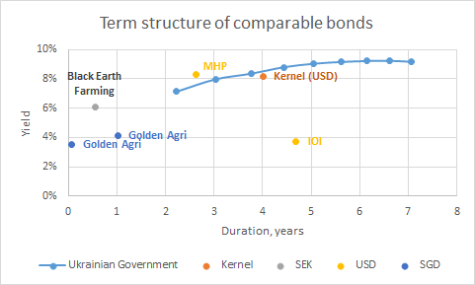
In the event of downgrade we can expect bond yields to rise over sovereign ones (as latter are expected to be more liquid). This will cause bonds to loose 4% of its value.
Scenarios.
For scenarios construction following figures were used:
- Forward curves:
  - Wheat in Rouen, France
  - Oats in Chicago, USA
  - Palm oil in Malasia
  - Corn in Chicago, USA

Exhibit 1. Key financials of Kernel and other comparable companies
Name | Country | Price to Earnings (TTM) | beta | Market Capitalization, mio | Price to Sales (TTM) | Price to Book (MRQ) | Price to Tangible Book (MRQ) | Price to Cash Flow (TTM) | Quick Ratio (MRQ) | Current Ratio (MRQ) | Long Term Debt to Equity, % (MRQ) | Total Debt to Equity, % (MRQ) | Interest Coverage (TTM) | Gross Margin, % (TTM) | Operating Margin, % (TTM) | Net Profit Margin, % (TTM)
Kernel Holding SA | Ukraine | 5,75 | 0,49 | 1 483 | 0,73 | 1,36 | 1,58 | 4,63 | 0,71 | 1,6 | 4,58 | 56,63 | 2,98 | 20,76 | 14,38 | 12,95
Edible oil producers
Astra Agro Lestari Tbk PT | Indonesia | 13,34 | 0,28 | 2 158 | 2,04 | 1,38 | 1,69 | 9,24 | 0,50 | 1,03 | 12,35 | 23,93 | 2,81 | 26,03 | 18,83 | 14,97
Sampoerna Agro Tbk PT | Indonesia | 47,90 | 0,65 | 283 | 1,61 | 1,24 | 1,28 | 10,38 | 0,44 | 1,03 | 85,61 | 116,77 | 4,59 | 21,98 | 15,34 | 15,76
Eagle High Plantations Tbk PT | Indonesia | -- | 1,13 | 765 | 4,62 | 1,64 | 2,03 | 19,39 | 0,54 | 0,74 | 112,91 | 142,14 | 0,91 | 12,28 | 0,38 | -18,03
Wilmar International Ltd | Singapore | 16,44 | 1,2 | 16 195 | 0,39 | 1,11 | 1,61 | 8,72 | 0,74 | 1,16 | 30,82 | 118,73 | -- | 9,69 | 3,62 | 2,64
Golden Agri-Resources Ltd | Singapore | 8,77 | 0,44 | 3 531 | 0,49 | 0,86 | 0,91 | 4,70 | 0,67 | 1,02 | 31,88 | 75,64 | 1,00 | 14,07 | 2,44 | 5,59
First Resources Ltd | Singapore | 17,97 | 0,73 | 2 252 | 3,92 | 2,56 | 2,92 | 11,95 | 0,83 | 1,08 | 25,38 | 50,82 | 7,25 | 46,46 | 36,11 | 22,91
Kencana Agri Ltd | Singapore | -- | 0,74 | 85 | 0,61 | 1,95 | 1,95 | 12,85 | 0,51 | 0,72 | 553,55 | 655,88 | 0,19 | 14,16 | 7,80 | -6,43
IOI Corporation Bhd | Malaysia | 40,00 | 0,93 | 6 804 | 2,38 | 4,10 | 4,54 | 22,85 | 1,00 | 1,96 | 83,57 | 104,74 | 1,28 | -- | 10,58 | 5,97
Kuala Lumpur Kepong Bhd | Malaysia | 22,52 | 0,97 | 5 904 | 1,48 | 2,34 | 2,42 | 15,48 | 1,29 | 1,89 | 26,70 | 44,74 | 10,88 | -- | 8,11 | 6,96
Genting Plantations Bhd | Malaysia | 25,64 | 1,06 | 2 099 | 6,28 | 1,97 | 2,00 | 19,68 | 5,01 | 5,50 | 49,53 | 50,15 | 9,82 | 42,64 | 36,18 | 25,00
China Agri-Industries Holdings Ltd | Hong Kong | -- | 1,47 | 2 609 | 0,24 | 0,79 | 0,83 | 17,95 | 0,66 | 1,06 | 6,57 | 137,86 | 0,89 | 7,00 | 2,48 | 1,72
Thai Vegetable Oil PCL | Thailand | 9,83 | 0,67 | 783 | 0,96 | 3,17 | 3,18 | 8,70 | 1,29 | 4,10 | 0,00 | 0,00 | -- | 15,99 | 11,50 | 9,98
Grain traders
Archer Daniels Midland Co | USA | 21,03 | 0,89 | 26 030 | 0,42 | 1,52 | 1,93 | 11,90 | 0,93 | 1,60 | 37,87 | 40,36 | -- | 5,88 | 2,54 | 2,07
Bunge Ltd | USA | 15,92 | 1,04 | 11 184 | 0,26 | 1,73 | 1,74 | 8,69 | 0,82 | 1,44 | 42,96 | 67,08 | 7,15 | 5,65 | 2,47 | 1,82
Andersons Inc | USA | 94,86 | 1,26 | 1 080 | 0,28 | 1,39 | 1,79 | 10,94 | 0,47 | 1,32 | 51,28 | 61,16 | -- | 8,80 | 0,46 | 0,37
Graincorp Ltd | Australia | 67,42 | 0,93 | 1 584 | 0,50 | 1,19 | 1,66 | 11,82 | 0,99 | 1,56 | 45,44 | 67,70 | 1,50 | 18,19 | 0,29 | 0,74
Ukrainian and Russian peers
MHP SA | Ukraine | 16,31 | 1,44 | 1 033 | 0,91 | 1,53 | 1,63 | 6,20 | 1,36 | 2,16 | 146,45 | 182,65 | 0,66 | 28,47 | 27,73 | 6,06
Black Earth Farming Ltd | Russia | -- | 1,52 | 162 | 2,14 | 1,35 | 1,35 | -- | 0,61 | 1,41 | -- | 49,47 | 14,61 | 35,11 | -16,14 | -14,07
KSG Agro | Ukraine | 12,69 | 1,51 | 11 | 0,44 | -- | -- | -- | 0,17 | 0,34 | -- | -- | -0,03 | 20,88 | 55,05 | -11,61
Astarta Holding N.V. | Ukraine | 5,82 | -- | 429 | 1,28 | 1,63 | -- | 10,54 | 0,43 | 1,49 | 29,30 | 84,80 | -- | 32,83 | 38,06 | 20,44
Industrial Milk Company | Ukraine | 7,18 | 0,51 | 78 | 0,56 | 0,28 | 0,30 | 3,63 | 0,40 | 1,84 | 65,57 | 142,00 | -- | 2,52 | 43,74 | 8,80
Industry average |  | 21,69 |  |  | 1,94 | 3,47 | 4,42 | 15,17 | 1,41 | 1,82 | 30,15 | 55,05 | 5,88 | 30,80 | 13,21 | 8,87
rates as of 24/03/2017

Further things to consider:
- for each segment: explore trends, perform SWOT analysis
- model ROE (or its DuPont sub) with oil/wheat spread and try arbitrage-free pricing
- Check interest
- 3 positives and 3 negatives

